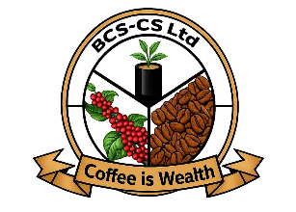
Kitagata Road, 200m off
BANYANKOLE COFFEE SERVICES CO-OPERATIVE SOCEITY LIMITED

Mbarara-Bushenyi Road,
P.O BOX 101 Kabwohe- Uganda.
Tel:+25782334786/781505854
Email: bcoffeeservices@gmail.com
REG NO. 12466/RCS, FLO ID 34484

About BCS-CS LT
Banyankole Coffee Services is a 1st grade fairtrade coffee organization of small holder farmers operating in Greater Bushenyi Districts, with head office in Sheema District, Uganda. With current membership of 1,616. Established to market Uganda Natural Robusta Coffee worldwide to increase household incomes for the peasant farmers in the region. Our coffee is processed naturally and certified Fairtrade, (FLO). FLO ID 34484, Focus on high quality, Timely shipment and with high respect for orders. Coffee is grown at an altitude of 1200m-1700m. At BCS-CS Ltd, Quality control is a key, seedling selection-Garden maintenance- Improved post harvesting- Improved drying methods/ natural processing. With this unique quality control mechanism, we meets all market standards.
WE OFFER,
- Purely Green Natural Uganda Robusta of high quality that competes favorably in the world market in different sizes (Scr.1200,1500.1800) and FAQ at unique demand. Pure red cherries are harvested, well prepared and dried naturally on tarpaulins and mats on sunshine, well dried coffee is hulled to produce FAQ-Fair Average quality, FAQ is further graded to produce different exportable grades as described above.
- Honey production alongside coffee as an alternative income generating project to the farmers.
- Members receive trainings in environment, agroforestry, EUDR compliancy, fairtrade standards, climate smart agriculture, gender awareness, child labour and forced labour among others to remain fairtrade compliant and obey the laws of the land all Funded by FT social premium.
SUSTAINABILITY APPROACH
- Increasing coffee Production in our operational area by enough seedlings supply.
- Training and involving youth in coffee value chain.
- Supply of Good quality coffee to our partners without compromise.
- Training and supporting farmers on value addition.
- Availability of enough product from the farmers.
- Integrating beekeeping and organic farming systems.
- Conducive political environment.
- Availability of good prices at household level.
Farmers coffee is sold to premium markets to enable them have stable incomes for their families.

Certifications & Traceability
- Fairtrade (FLO) certified
- EUDR compliant
- Organic certification by default
Active partners#---Add on existing
- Shared interest Foundation- Grant in Agroforestry, Bees for business and climate smart agriculture
- CBI (Netherlands) – market development product branding
- Root Capital – contract financing and technical assistance
- Shared interest society -Export facility
- Fairtrade Africa- Fairtrade standards advisory services, market and product traceability compliancy
- MAAIF-Uganda coffee quality regulator

WORK WITH US-why?
- Availability of 1,800,00 kgs from farmers annually.
- Good quality natural coffee from the origin.
- Respect for contracts and timely shipment.
- Consistent quality and transparent communication.
- Preservation of natural environment in the community beyond coffee farms.
- Strong relationship with smallholder farmers for sustainability.
- Provision of certified coffees under Fairtrade Certificate (FLO), with applicable standards on SPOs.
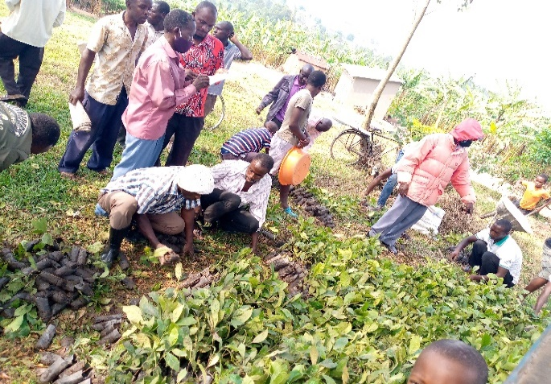
- Consistent increase in sales in metric tons for 3 years respectively, (400+, 500+,600+)
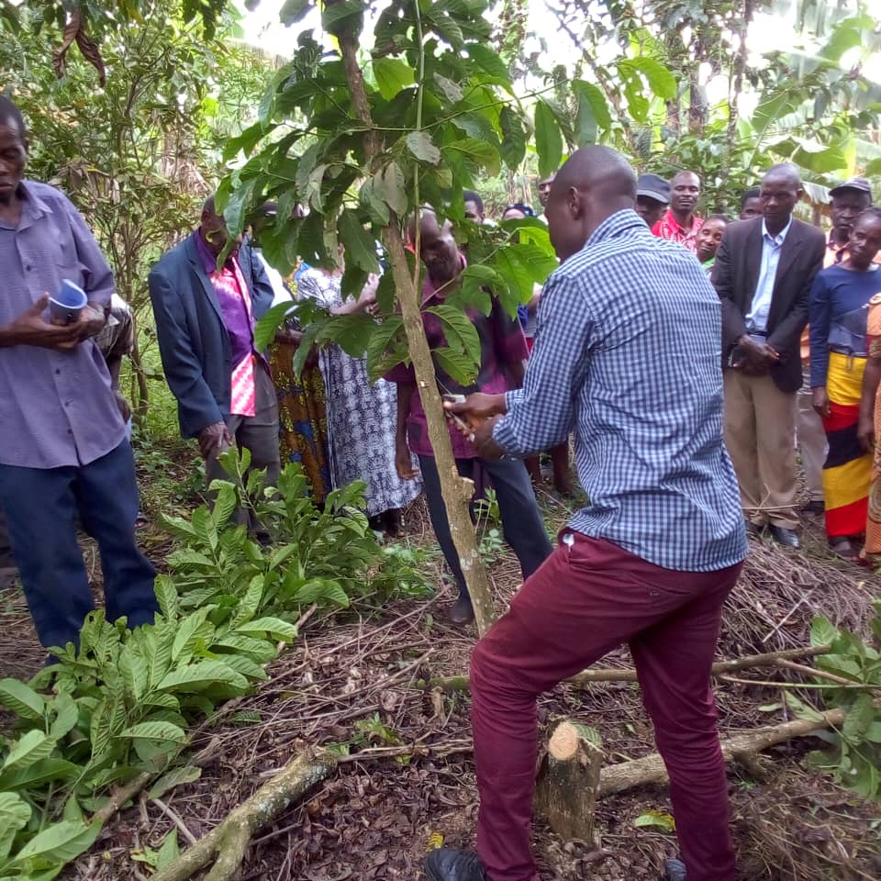

Farmers taking coffee seedlings Agronomy trainings to farmers
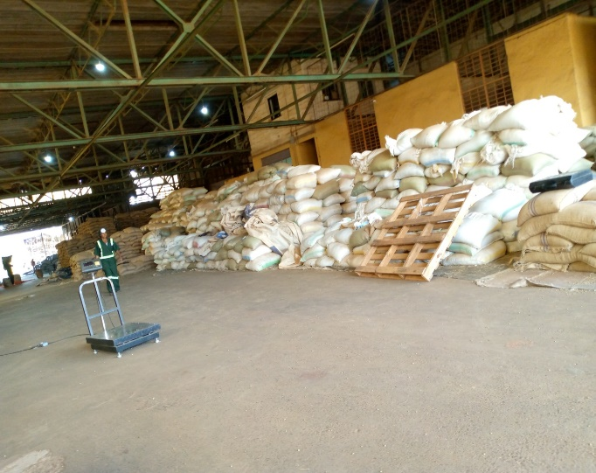
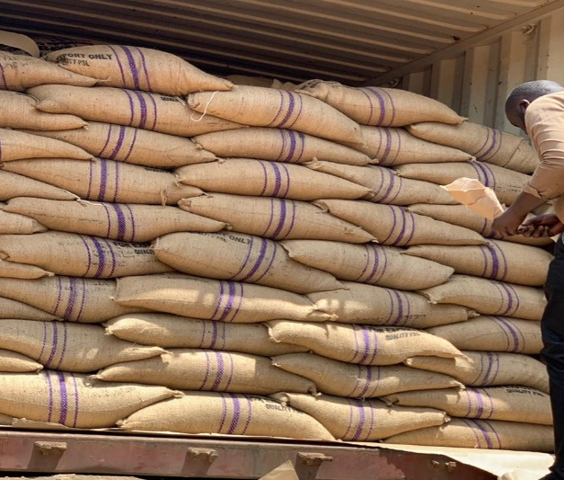

Coffee processing & storage Coffee loading for export
CONTACT DETAILS:
MANAGER: KURUBAIJA LAUBEN ENOCK
PHONE: +256782334786/+256700761080
Email: kurubaijalaubenenock@gmail.com/bcoffeeservices@gmail.com
Website: https://banyankolecoffee.com

